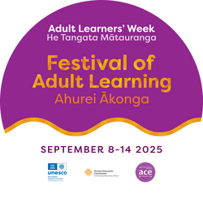

August 18 2025

**Celebrating the Joy of Learning**

The annual Adult Learners’ Week Festival September 8-14, 2025 is a reminder that community learning is powerful and transformative. It affects wellbeing, builds community and helps us make sense of the complex world we live in.

For over twenty -five years Adult and Community Education (ACE) Aotearoa has been encouraging communities to celebrate the benefits of lifelong learning. This year’s celebration will focus on kōrero around the joy that learning brings to individuals experiencing loneliness, people trying to manage challenge and change, understand the digital world or have some fun.

More than forty event organisers will offer programmes of events to celebrate learners and showcase their work, encourage people to find out about what’s on offer and have a go at something new.

Fifteen branch libraries in Tamaki Makaurau will be running programmes of events such as drop-ins focusing on all things technology, creating a memoir, Spring Aromatherapy, Zines, AI for Beginners and more. English Language Partners New Lynn is offering sample English classes for new migrants and in Whanganui, Community Education Whanganui will be hosting Voices and Visions, a group exhibition of student and tutor art work.

ACE Sector Capability Manager Tai Samaeli says Adult Learners’ Week is a chance to reflect on the importance of affordable, accessible learning in community settings and the way it combats growing social isolation. “Lifelong learning empowers individuals and whānau to fully participate in the life of their communities.”

Over forty countries celebrate Adult Learners Week He Tangata Mātauranga. The UNESCO initiative which includes International Literacy Day on September 8, promotes learning as a pathway to wellbeing and self- determination.

For event information see the website

<https://www.aceaotearoa.org.nz/events/adult-learners-week-he-tangata-m%C4%81tauranga>